Metropolis Hastings Algorithm

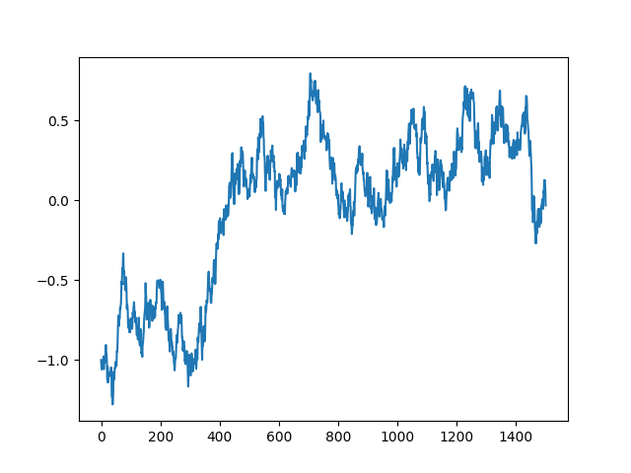
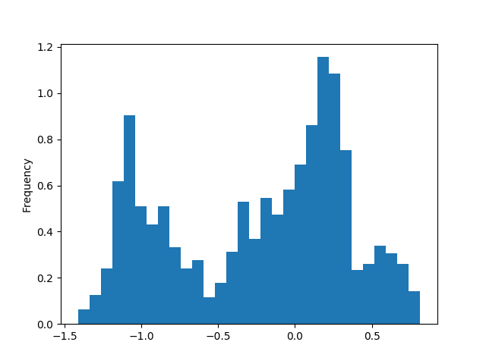
Samples vs iteration Histogram of samples

Standard deviation = 0.05

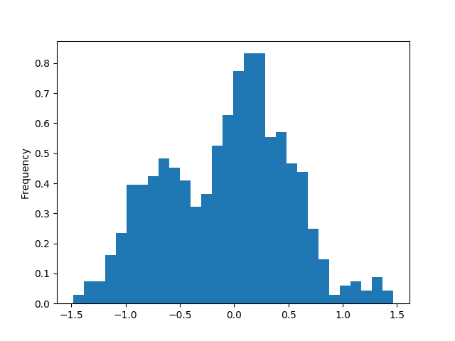
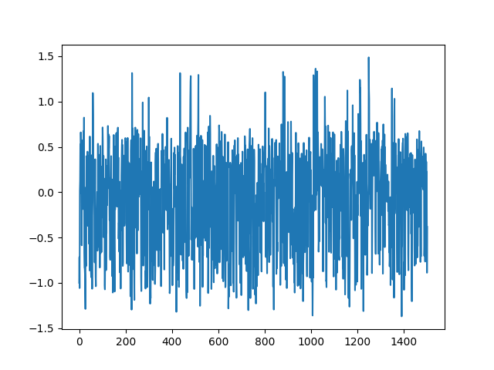
Samples vs iteration Histogram of samples

Standard deviation = 1

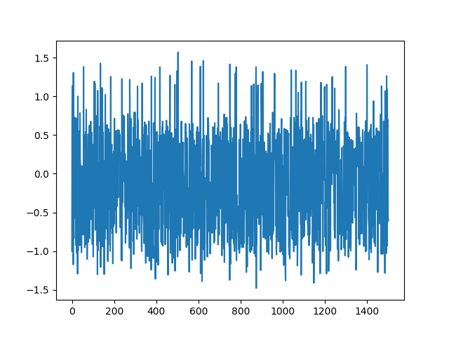
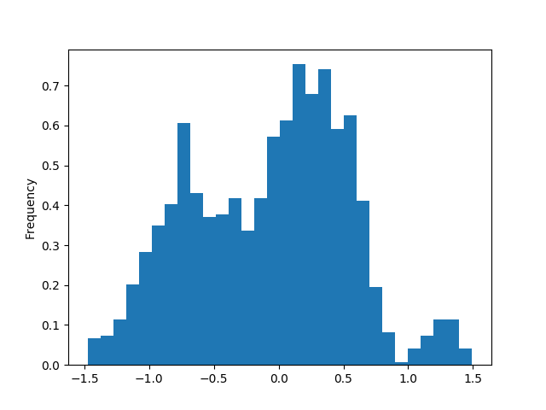

Samples vs iteration Histogram of samples

Standard deviation = 50

Conclusion:

On increasing the value of standard deviation, the generated candidate sample happens to come from a wider range of values than for a lower value of standard deviation. Also, with higher values of standard deviation, the generated candidate sample happens to be rejected more times than for lower values of standard deviation, hence the algorithm runs slower for higher values of standard deviation. Also, as can be seen from above histograms, the candidate samples generated more or less resemble the target distribution for each of the standard deviation(sigma) values.

